

***LAB # 01***

*To study the concepts of String Constant Pool, String literals, String immutability and Wrapper classes.*



October 21, 2024

***LAB TASKS***

***TASK # 01***

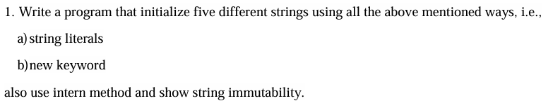

*INPUT*

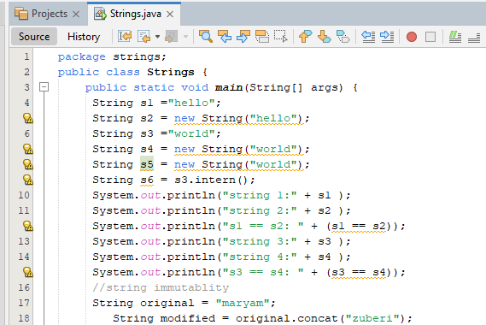

**

*OUTPUT*

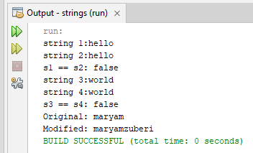

***TASK # 02***

**

*INPUT*

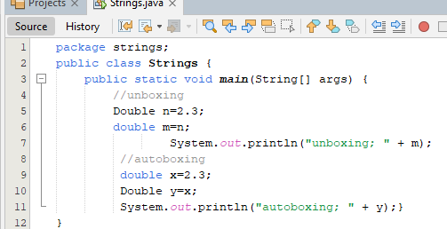

*OUTPUT*

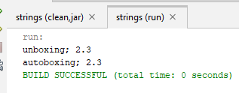

***TASK # 03***

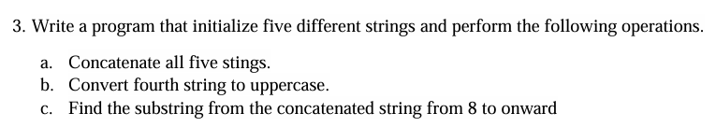

*INPUT*

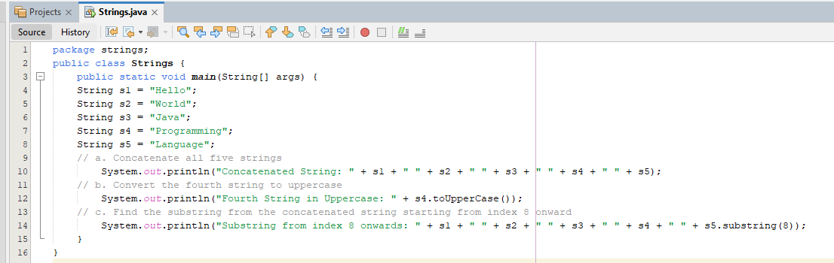

*OUTPUT*

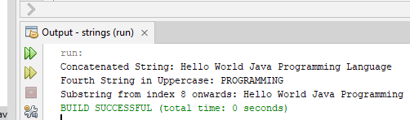

***TASK # 04***

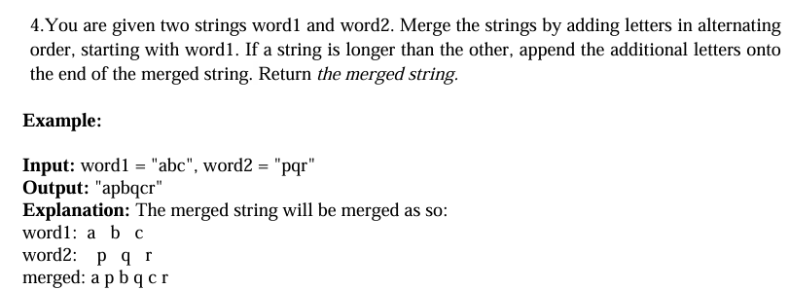

*INPUT*

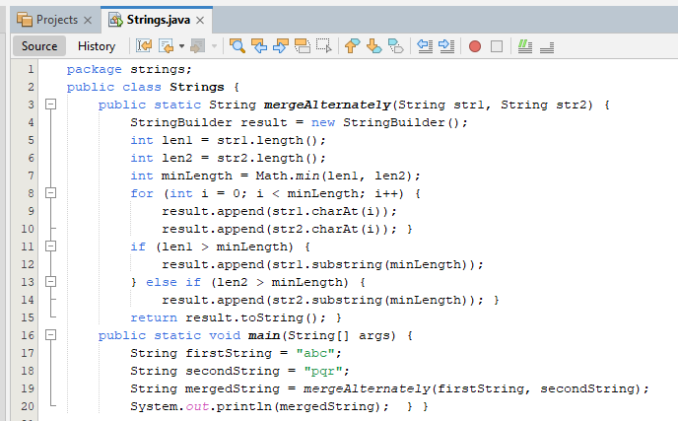

*OUTPUT*

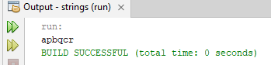

***TASK # 05***

**

*INPUT*

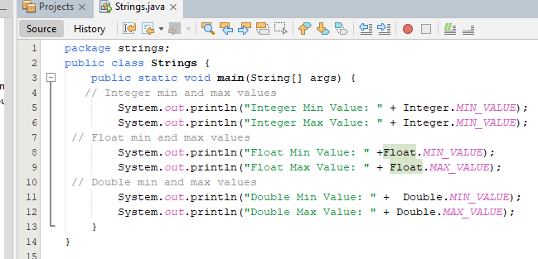

*OUTPUT*

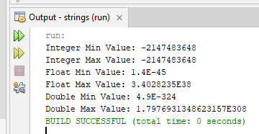

***HOME TASKS***

***TASK # 01***



*INPUT*

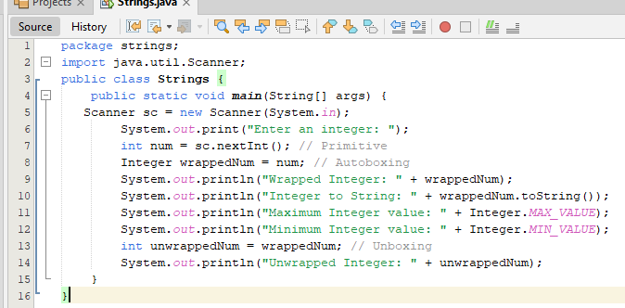

*OUTPUT*

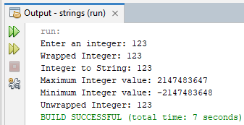

***TASK # 02***



*INPUT*

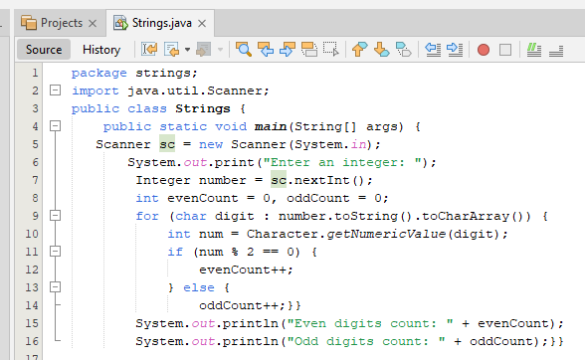

*OUTPUT*

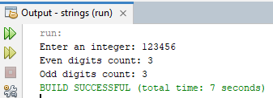

***TASK # 03***



*INPUT*

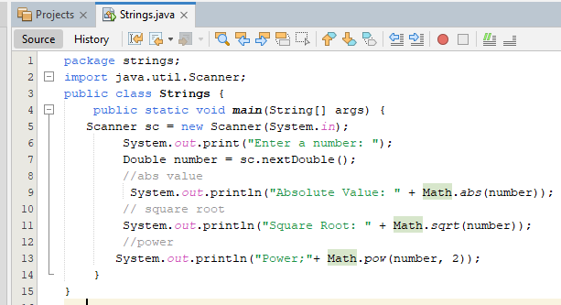

*OUTPUT*

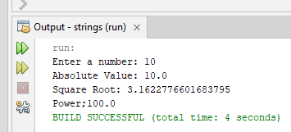

***TASK # 04***



*INPUT*

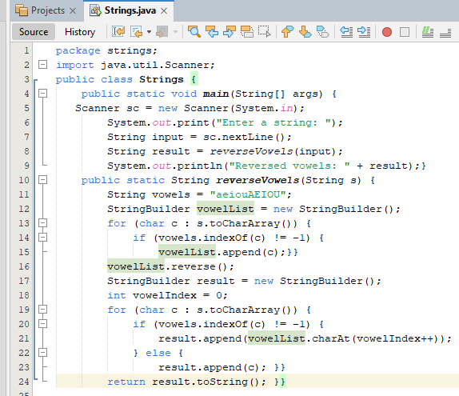

*OUTPUT*

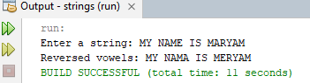

***TASK # 05***



*INPUT*

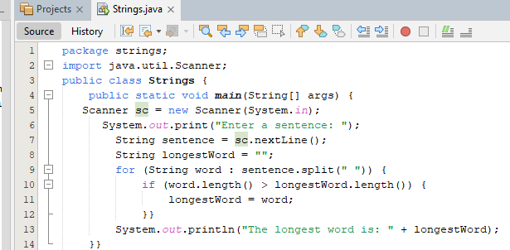

*OUTPUT*

